**Graphic Display**

Revenue 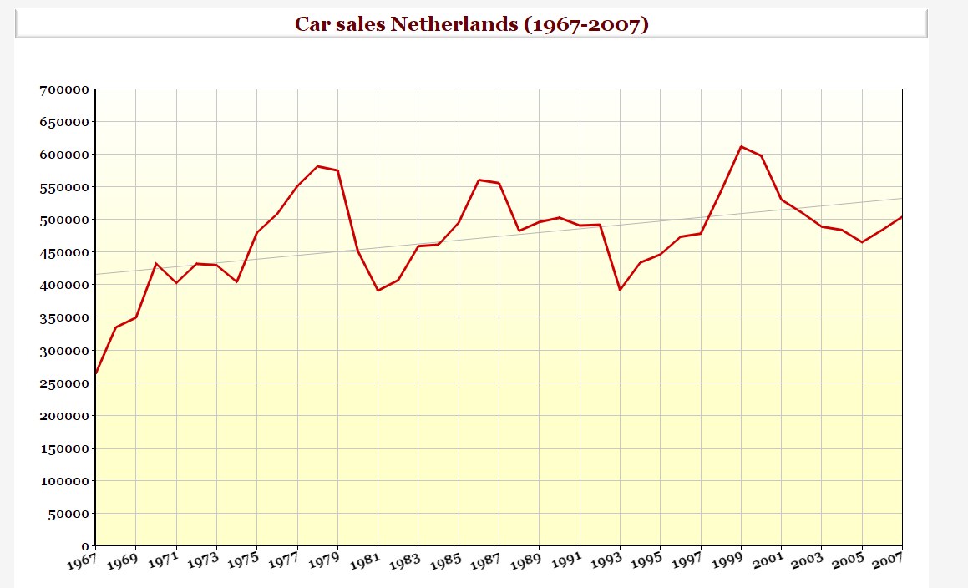

Years

**Aspects that Affect Sense making**

As this Graphs Explains about the Car Sales in Netherlands between the period of 1967-2007 and shows the sales of Each year and the revenue generated with the help of the graphs. This is a result of a growing line-up, filling all niches, and creating new ones in the premium segment of the market. For example, the subcompact [model](http://carsalesbase.com/european-car-sales-data/audi/audi-a1/) was introduced in 1975 and added almost 100000 annual car sales. As the Gestalt is also known as the "Law of Simplicity” which states that every stimulus is perceived in its most simple form. As in the Current Scenario Graph simply displays about the sales of the Car in Netherlands and the rise and the Fall of the sales, which is Clearly displayed according to the Gestalt principles. As the graph shows about the sales and in the Current Sales Scenario After every time the sales get dropped the Companies or the Govt makes come changes may be in the tax systems or some new policies been implemented which certainly boosts the car sales. Similarity: - It states things that are similar are perceived to be more related than things that are dissimilar. In the above Graph, the similar sales data can be put together for the sales analysis. Proximity: - things that are close to one another are perceived to be more related than things that are spaced farther apart, In the Current graph the two groups of highest sales and the lowest sales years can be formed. Closure: - When looking at a complex arrangement of individual elements, humans tend to first look for a single, recognizable pattern. If the highest sales and the lowest sales years can be formed, we can check the recognizable pattern in the sales data. Good Continuation Elements arranged on a line or curve are perceived to be more related than elements not on the line or curve.

**Analysis of the graph.**

**Scene: -** The scene is defined as “a semantically coherent (and often name-able) view of a real-world environment comprising background elements and multiple discrete objects arranged in a spatially licensed manner. The annual Netherlands *Vehicle Market Statistics* offers a statistical portrait of passenger car and light-commercial vehicle fleets in the Netherlands from 1967— 2007. The emphasis is on vehicle sales based on fuel consumption, and emissions of greenhouse gases and other air pollutants. It also provides about the insight of the predicted sales and the actual sales of the cars between the period of 1967-2007. In this figure, the X and Y axes as well as the coordinate field are the scene which are Years and Sales price are the Scene of the Scenario.

**Objects**: - Objects are defined as “small-scale discrete entities that are manipulee (e.g. can be moved) within the scene”. Restated, objects are related to scenes in that scenes are understood to be background elements that cannot be moved or altered, while objects are entities that may appear in different locations in the scene. In the Current Scenario, the Objects are the Red line which moves around the X and Y axis defining the sales in the year.

**Characteristics: -** Henderson and Hollingworth characterization of visual representations by noting that objects possess characteristics, attributes of objects that allow qualities of the objects to be observed or allow objects to be compared to one another. In the Car sold in Netherlands Year-Sales graph (scene) contains lines (objects) that can be distinguished by gray lines and the Red Lines which are the Characteristics of the Graph. Characteristics of objects include their size, texture, orientation, shape, and other sources of differentiation. In this scenario, the characteristics differentiate

**Strengths and Weaknesses of the Graph**

**Strengths: -**

* Shows range, minimum & maximum, gaps & clusters, and outliers easily
* Quick analysis of data
* Exact values retained
* Easy representation of Data

**Weaknesses: -**

* Not as visually appealing
* Best for under 50 data values
* Needs small range of data
* Cannot Provide difference between predicted and actual values.

**Analysis of Figure Checklist**

1. Is Figure being necessary: - Yes, it is necessary as to show the results.
2. Is Figure simple and clear: - Yes, it is simple and clear.
3. Is Figure title descriptive: - Yes, it is descriptive.
4. Is Figure elements clearly labeled descriptive: - Yes, it is descriptive.
5. Is Figure magnitude, Scale clearly labeled descriptive: - Yes, it is descriptive.
6. Are all figures mentioned in the Text: - Yes, it is mentioned.
7. Is Figure submitted in accepted file format: - Yes.